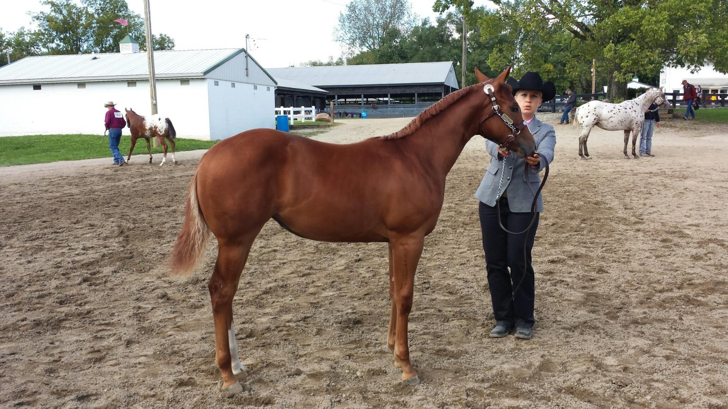

I.A.A. FUTURITY CHAMPION OF CHAMPIONS FOR 2014

Pictured above is Small Town Throwdown with her exhibitor/owner Stephanie Sickafoose-Ungerer. This filly won first place in the I.A.A. Open Filly class and second place in the Indiana Owned Sire and Dam class. The filly’s sire is Mr Awe Dacity and the dam is Koolette. Congratulations to Stephanie!!